Databricks Use Case Registration

Resources (access via @v-dev.io email):
How to Register an Opportunity
Register a Use Case
Databricks Portal

Disclaimer:
Databricks generally will not directly reach out to any customer contacts provided by the partner (e.g. contacts not separately known to Databricks). Our preferred practice is to engage with such contact through the partner.
If you are required to adhere to specific legal privacy practices, we kindly ask that you ensure these practices are properly applied. In particular, we request that you capture the contact's acceptance to share their details in the Notes section.
For reference, please review our policies at https://databricks.com/gdpr-faqs.
**If you do not see consumption information within one month of deployment, please contact ww_pdr_support@databricks.com for assistance.**
If you are unable to provide the customer contact details, kindly include the appropriate explanation in the "Use Case Details" section.

Partner Deal Registration SLA (For Partners and Databricks - AMER, EMEA & APAC)
- Databricks X Development Representative (XDR) will begin to process the partner-submitted lead upon receiving the completed form.
- The Databricks XDR may request additional details or inputs from the partner contact regarding the submitted deal registration. The Databricks XDR will generally contact the partner directly (via email) within two business days*.
- Partner contacts are expected to respond to the Databricks XDR within three business days of receiving the XDR request.
- If no response is received from the partner contact within three business days, Databricks XDR may decline or disqualify the deal registration request.
**Please note, this timeframe excludes weekends and public holidays**.
Please note that all fields are mandatory to ensure we can assist you effectively by gathering the accurate information needed to evaluate your use case.

Use Case Registration - Rio Tinto Project

Partner Information

Partner Primary Sales Contact Name | Raissa Amaral
Partner Primary Sales Contact Email Address | raissa.amaral@visagio.com
Partner Primary Sales Contact Phone No | 0426799001

Customer Information

Enter the end customer information. Please ensure if you are under GDPR policies you are following those policies. Our specific ask is to capture acceptance by the contact to share their details in the 'Use Case Detail' section.
The information input into the use case registration will be used to help qualify the use case and connect our teams to progress this and drive success with the customer together. We will not engage the customer with your registered information, without you.
Please see our policies at https://databricks.com/gdpr-faqs.

Customer Company Name | Rio Tinto
Customer Website | https://www.riotinto.com/
Address | 152-158
Street | St Georges Terrace
City | Perth
State/Province | WA
Zip/Postal Code | 6000
Country | Australia
Customer Contact First Name | Josh
Customer Contact Last Name | Chen
Customer Contact Email | Josh.Chen@riotinto.com
Customer Contact Role / Title | Senior Data Engineer
Project Decision Maker | Technical Decision Maker | 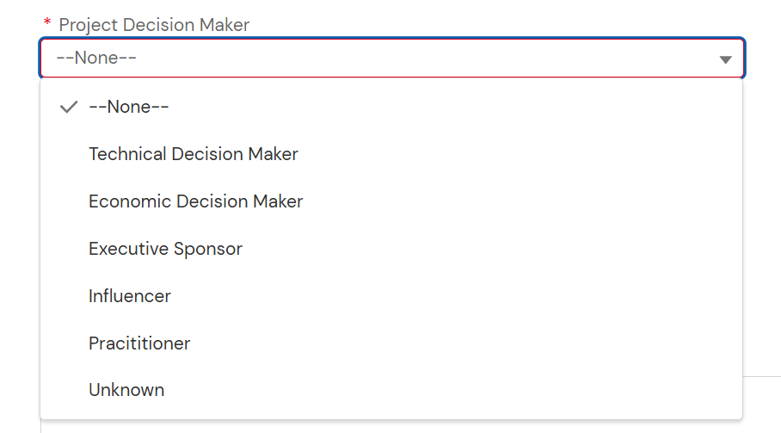

Opportunity Information

Use Case Description | Daily Performance Insights (DPI) automates operational intelligence and delivers a prioritized email digest to leaders before the daily 8:00 AM meeting (target delivery 7:15–7:30 AM AWST). The solution consumes operational performance data from the CORD (Central Operations Reporting Database) semantic model by executing parameterized DAX queries, producing structured/tabular JSON records for downstream processing. DPI generates insights via a staged AI pipeline producing confidence-rated, traceable insights with. Current implementation is on Microsoft Power Platform (Power Automate orchestration + AI Builder models, Power Apps for subscriptions, SharePoint for config) | Please share the title (if known) or primary subject of the use case
Next step with Customer | Proposal | 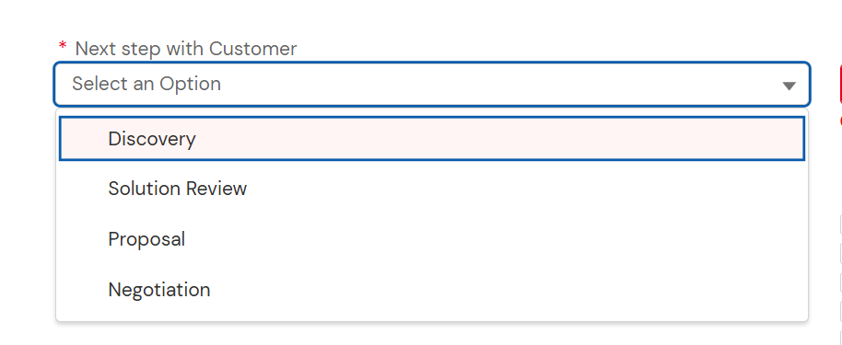
Does Customer have an allocated budget for this?: | Yes | Yes/No
Estimated Databricks $ARR of the Opportunity | <25,000 | 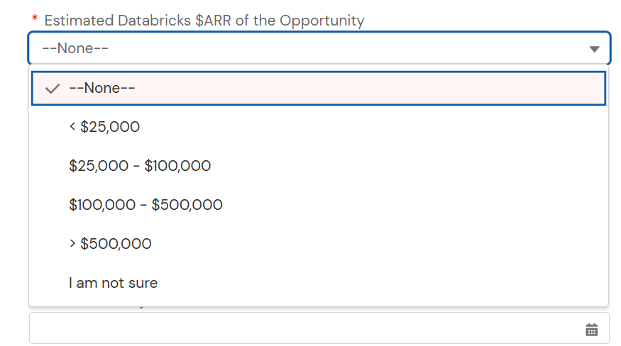
Product Utilized | AI  Interactive Notebooks  DWH  AI/BI  Lakeflow Jobs  Lakeflow Pipeline  Unity Catalog | 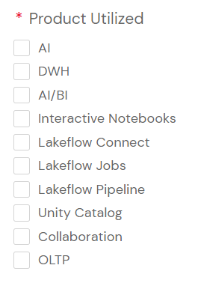
Estimated Project Start Date | 01/03/2026
Estimated Use Case Go-Live Date: | NA
Existing Engagement with Databricks Account Executive or SA: | Yes | Yes/No
Is this the subject of a RFP or public tender: | No | Yes/No
Existing Master Service Agreement (MSA) with Customer | Yes  (Would fall under the agreement Visagio has with RT) | Yes/No
Competitors (if any): | -
Will this opportunity run on AWS, GCP or Azure? | Azure  (Likely with RT environment, otherwise could put Other) | 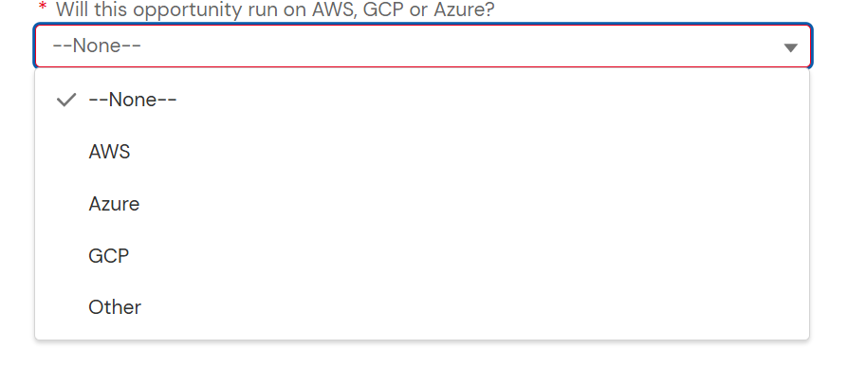

Campaign & Programs

Brickbuilder Solution or Accelerator? | Migration | 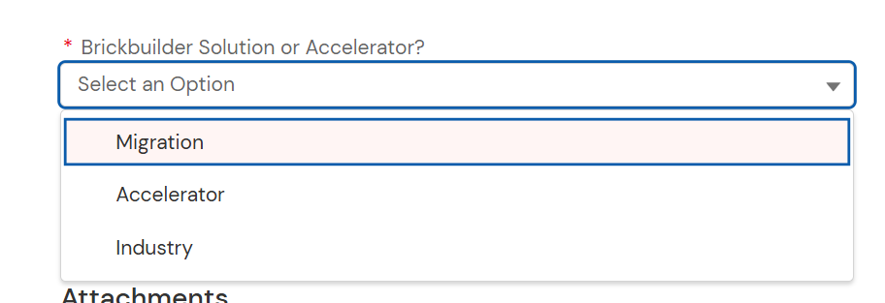
Is this related to a campaign | No | Yes/No
Campaign | -

